**IMPLEMETTING AN APPLICATION**

|  |  |
| --- | --- |
| **Date** | 19 October 2022 |
| **Team Id** | PNT2022TMID07988 |
| **Project Name** | Inventory Management System for Retailers |
| **Maximum Marks** | 4 Marks |

**HOME PAGE**

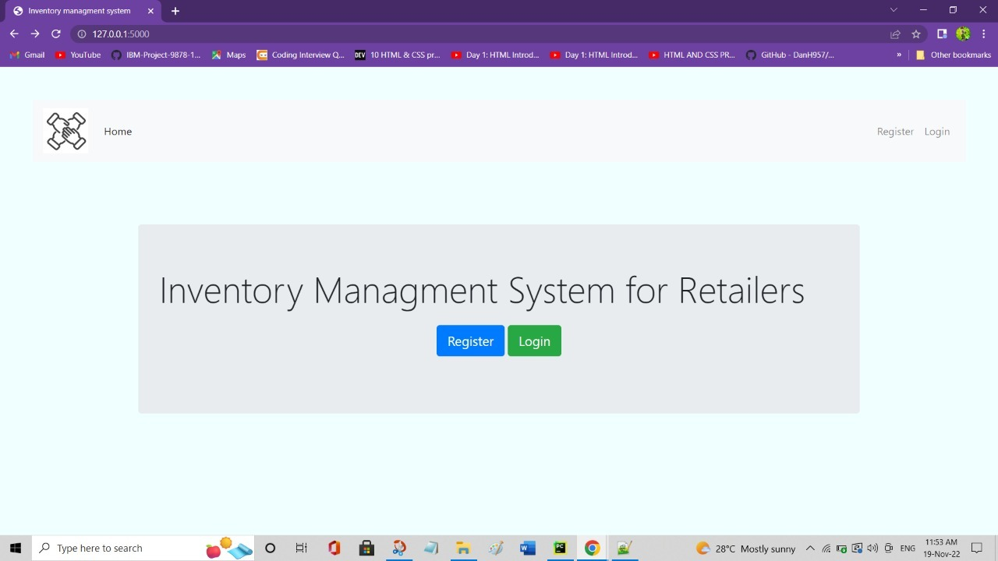

**REGISTER PAGE**

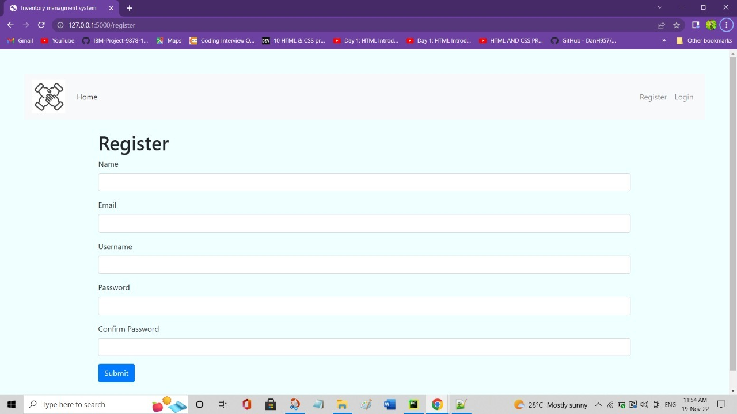

**LOGIN PAGE**

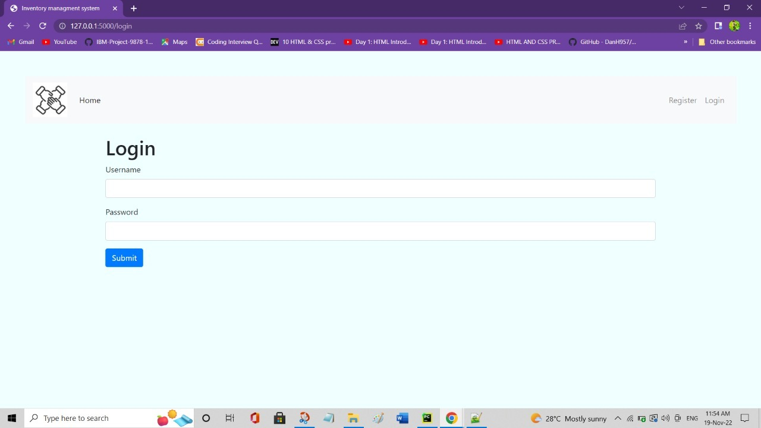

**DASHBOARD**

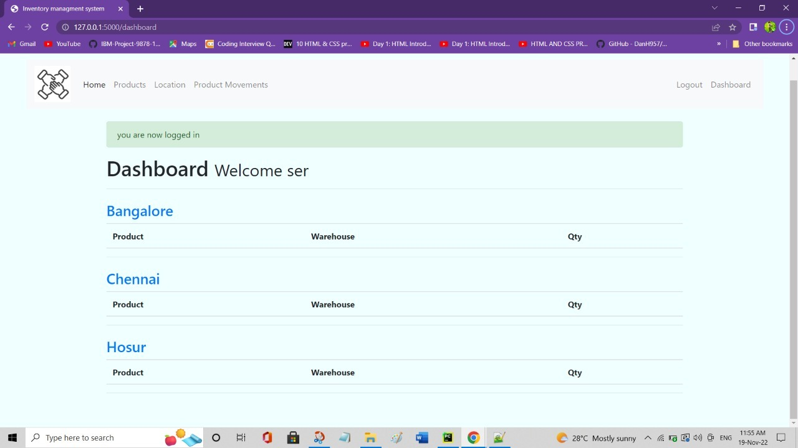

**PRODUCT**

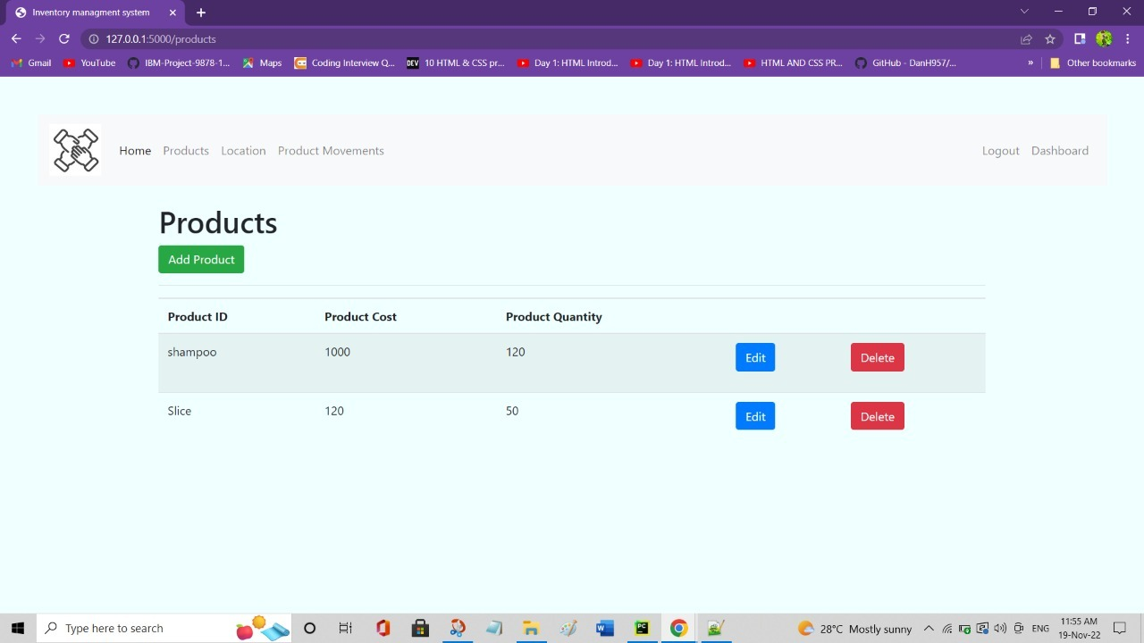

**LOCATION**

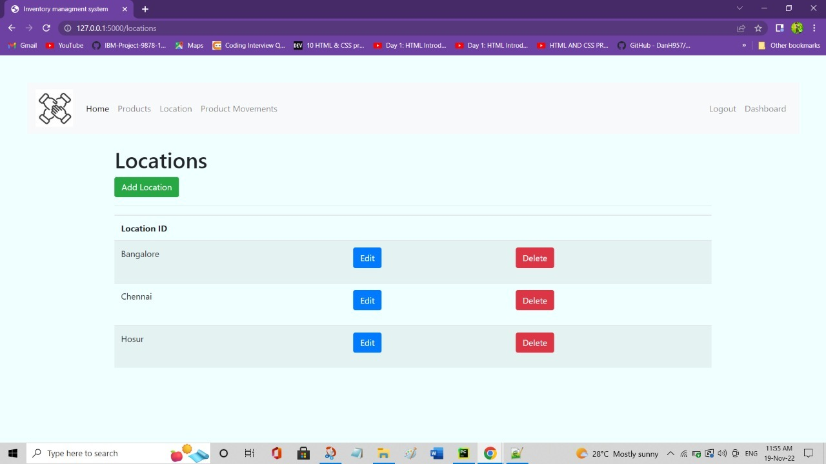

**PRODUCT MOVEMENT**

